EXP 04 : Measurement and Analysis of Dispersion Compensation in Optical Fiber using OptiSystem
OBJECTIVES :
1. To demonstrate dispersion compensation using the Ideal Dispersion Compensation component in OptiSystem.
2. To observe the broadening of a 12.5 ps optical Gaussian pulse after propagation through 10 km of single-mode fiber (SMF).
3. To compensate the accumulated dispersion of 160 ps/nm and verify recovery of the original pulse shape.
SOFTWARE REQUIRED : Optisystem software
CIRCUIT DIAGRAM:
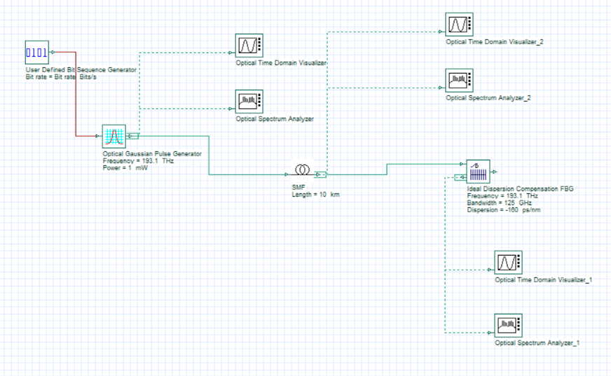
OUTPUTS:
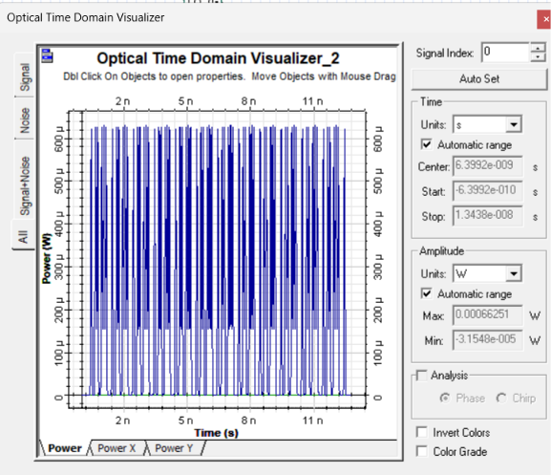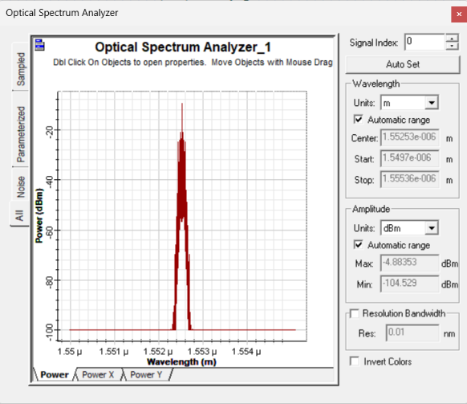

REFLECTION:
I leanred how to simulate dispersion compensation in Optisystem and observe pulse broadening after propagation through 10 km of SMF. I verified that setting the compensator dispersion to -160 ps/nm restores the original Gaussian pulse shape
RUBRICS:
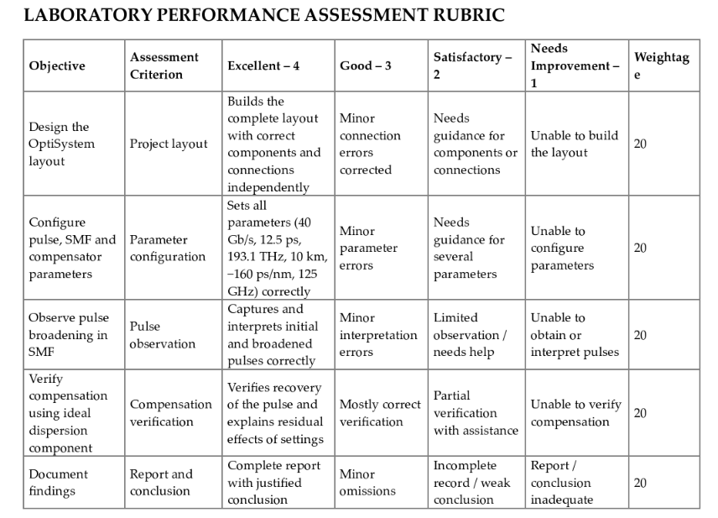
RESULT:
Dispersion compensation was successfully demonstrated using the Ideal Dispersion Compensation component in OptiSystem. A 12.5 ps Gaussian pulse broadened approximately four times after 10 km of SMF (accumulated dispersion 160 ps/nm), and se ing the compensator dispersion to –160 ps/nm restored the pulse, achieving an exact compensation of the accumulated dispersion.

